Schistosomiasis for Travellers
What is Schistosomiasis?
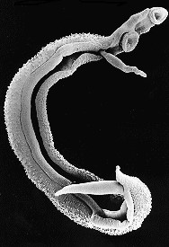
- Schistosomiasis (also known as Bilharzia, after Theodor Bilharz, who identified the parasite in 1852) is a disease caused by parasitic blood flukes (schistosoma worms)
- The disease has acute and chronic forms and is responsible for more than 240 million infections worldwide
- Schistosomiasis has a complex life cycle, which involves snails, living in freshwater (such as lakes, rivers and ponds) as the host species. The larval forms (called cercariae) emerge from the snails and contaminate the water. Individuals become infected when skin comes into contact with the water and the cercariae penetrate the skin
- Once they have penetrated the skin, the cercariae develop and migrate to the liver and then, via the venous system, to the blood vessels of the bowel or bladder, where mature worms mate and produce eggs. The eggs are then passed into the environment via urine or faeces and the cycle begins again
Male and female adult worms
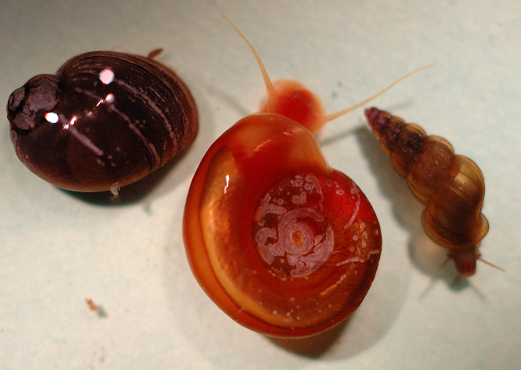
- There are various types of schistosomiasis flatworm which affect humans
- The main organisms of concern are Schistosoma haematobium, S, mansoni, S. japonicum, and S. mekongi
- The flatworms cause damage to either the urinary tract (including bladder and kidneys) or the gastrointestinal system (including the liver)
- Schistosomiasis is a neglected tropical disease, which mainly affects poor and rural communities; many affected countries now have health education and eradication programmes focusing on snail control and better sanitation.
From left, Bulinus truncatus truncatus (host for S. haematobium), Biomphalaria glabrata (host for S. mansoni), and Oncomelania hupensis hupensis (host for S. japonicum). From The NIH-NIAID Schistosomiasis Resource Centre

Where is Schistosomiasis found?
- Over 90% of people requiring treatment for schistosomiasis live in Africa. The highest prevalence destinations are Sierra Leone, Ghana, Tanzania, Mozambique and Madagascar.

Parasite species and geographical distribution - from the World Health Organisation
https://www.who.int/news-room/fact-sheets/detail/schistosomiasis

 | Species | Geographical Distribution
Intestinal schistosomiasis | Schistosoma mansoni | Africa, the Middle East, the Caribbean, Brazil, Venezuela and Suriname
 | Schistosoma japonicum | China, Indonesia, the Phillipines
 | Schistosoma mekongi | Cambodia, Laos
 | Schistosoma guineensis and intercalatum | Rainforest areas of central Africa
Urogenital Schistosomiasis | Schistosoma haematobium | Africa, the Middle East, Corsica

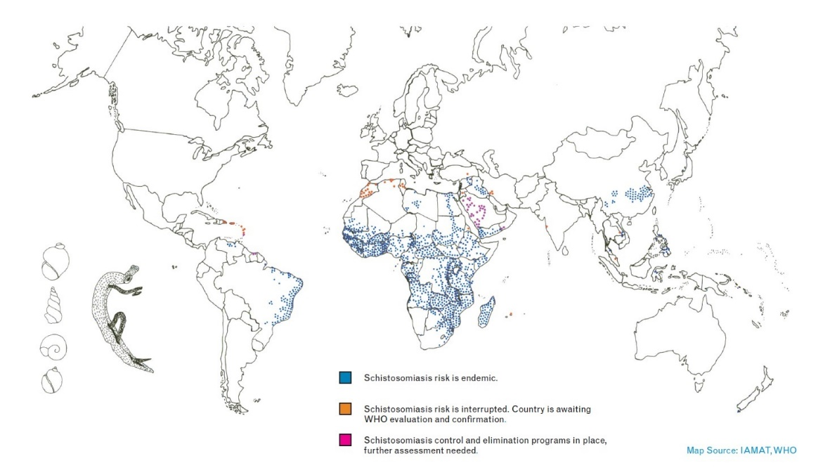

Risk for Travellers
- Most schistosomiasis in travellers is acquired in Africa, although it is present across the tropical regions of the world
- Travellers are at risk of schistosomiasis if they swim, wade or bathe in fresh water in endemic areas
- A rise in eco-travel and ‘off the beaten track’ adventure travel has led to an increase in schistosomiasis cases in travellers
- Swimming in Lake Malawi is an important risk factor
- Outbreaks have occurred in groups doing particular water-based activities such as river rafting

What are the symptoms of Schistosomiasis?
Swimmer’s Itch
Within hours or up to one week from exposure
- Initial contact with cercariae can cause itching, which is sometimes accompanied by a rash.
Acute Schistosomiasis or ‘Katayama Fever’
Incubation period is typically 14 – 84 days
- Acute schistosomiasis is due to an inflammatory response to the migration of the schistosomula through the body
- Acute schistosomiasis often presents with fever, malaise, urticarial (raised itchy skin rash), headaches, muscle aches, diarrhoea and respiratory symptoms. Enlargement of the liver and spleen can also occur.
Chronic Schistosomiasis
Without treatment, schistosomiasis can persist for years, often without symptoms
- Symptoms of chronic (long-term) schistosomiasis are the result of immune system response to eggs
- Longterm infection with S. mansoni and S japonicum causes scarring of the liver (fibrosis), with damage to the blood vessels of the liver and oesophagus (varices or dilated veins).
- Longterm infection with S. haematobium can cause blood in the urine and damage to the bladder, kidney obstruction, chronic urine and genital symptoms and increased risk of bladder cancer
- Rarely, neuroschistosomiasis can occur, when worms migrate to the brain and spinal cord. Symptoms include headaches, visual impairment, and limb weakness

- Signs and symptoms of schistosomiasis vary with the stage of the illness and the time from exposure
- Take home message – if you have been in an area where urinary schistosomiasis is transmitted and you develop blood in your urine, see your doctor and tell them your travel history; the symptoms of intestinal schistosomiasis are more non-specific and may be similar to other diseases – if in doubt, visit your doctor
- Schistosomiasis infection without symptoms can be common. If you are concerned that you may have had likely exposure, see your doctor on return

Diagnosis
- Travel and exposure history is essential in diagnosing schistosomiasis
- Blood, urine or stool testing may be required
- Increased numbers of eosinophil white blood cells (eosinophilia) may be a useful indicator
- Schistosome eggs may be seen on microscopic examination of stool or urine (this requires adult worms to be producing eggs, which may not occur until 8 weeks post initial infection)
- Blood tests can detect antibodies to schistosomal antigens (marker proteins) but these may not show up until 8-12 weeks post initial infection
- Sometimes samples of tissue may be taken from the back passage or other areas to make the diagnosis

What is the treatment?
- Praziquantel is the drug treatment of choice for all species of schistosomiasis
- Praziquantel is most effective against adult forms of the parasite and requires an immune response to the adult worms to be fully effective
- A single course is usually curative but, in lightly infected people, repeated treatment after 2-4 weeks may be needed
- Praziquantel does not work if taken too soon after exposure, so do not be tempted by the ‘swim and treat’ drug options available on the shores of Lake Malawi and elsewhere – these will not work and may not be safe

Tips on prevention of Schistosomiasis - Golden Rules

- No vaccine and no drugs are available for prevention
- In countries where schistosomiasis is found, avoid contact with fresh water – avoid wading, swimming or bathing in lakes, rivers or streams. There is no risk in seawater
- If you are planning a jungle or desert trip, ensure you have enough purified water and make your trip a short one to reduce the temptation to cool off in a freshwater oasis
- Wear high waterproof boots if you are needing to wade through swamps or streams
- Swimming in adequately chlorinated swimming pools is safe
- Avoid the banks of rivers and streams: snails are most common in shallow water where organic matter and aquatic vegetation is found. Snails are less likely to be found in the deeper areas of lakes, rivers and streams where water flow is faster
- Cercariae emerge from snails and are most active in the peak daylight hours so avoid contact with freshwater during this time
- If you do come into contact with fresh water, dry yourself vigorously with a towel and apply alcohol sanitising gel to reduce the likelihood of infection (this does not prevent infection reliably)
- Topical application of insect repellents containing DEET may block penetrating cercariae, but the effect may be variable and short-lived (and similarly, does not prevent infection reliably)
- Drinking water should be boiled, filtered or treated with chlorine tablets, as cercariae can penetrate through the mouth
- Piped water from a freshwater source may contain cercariae. Filtering with fine mesh filters, heating bathing water to 50° for 5 minutes, or allowing water to stand for over 1-2 d prior to exposure, can prevent infection

Useful Websites
Useful information on schistosomiasis awareness: https://www.iamat.org/assets/files/Be%20Aware%20of%20Schistosomiasis_2015.pdf
World schistosomiasis risk chart: https://www.iamat.org/assets/files/World%20Schistosomiasis%20Risk%20Chart_2015.pdf
For a great summary of the lifecycle, see:
https://www.cdc.gov/parasites/schistosomiasis/biology.html
For other useful information, see:
https://travelhealthpro.org.uk/disease-details.php?dis=159
https://wwwnc.cdc.gov/travel/yellowbook/2020/travel-related-infectious-diseases/schistosomiasis
https://www.who.int/news-room/fact-sheets/detail/schistosomiasis
https://www.cdc.gov/parasites/schistosomiasis/prevent.html

